05 March 2025

Study reveals how agave plants survive extreme droughts
Researchers use terahertz spectroscopy to explore how agaves retain water in dry environments, offering insights for drought-resistant crops
WASHINGTON — Agave plants may be best known for their role in tequila production, but they are also remarkably adept at retaining water in extremely dry environments. In a new study, researchers used terahertz spectroscopy and imaging to gain new insights into how these succulents store and manage water to survive in dry conditions.
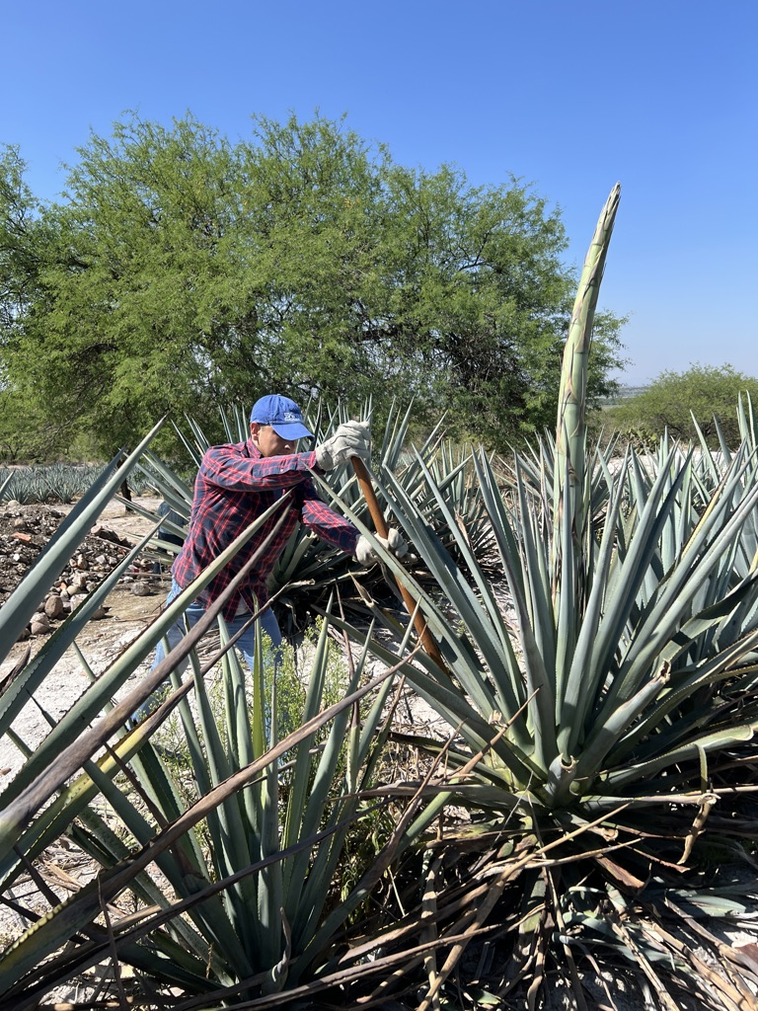
Caption: Researchers used terahertz spectroscopy and imaging to better understand how agave plants (pictured) store and manage water to survive in dry conditions.
Credit: : June Simpson, CINVESTAV
“Understanding how plants adapt to dry conditions could lead to better farming practices and be used to develop crops that require less water,” said Monica Ortiz-Martinez from the Centro de Investigaciones en Optica (CIO) in Mexico. “This could lead to higher crop yields with lower water consumption, benefiting farmers, food production and global food security.”
The new study utilizes terahertz waves, which fall between microwaves and the mid-infrared region of the electromagnetic spectrum. Because water strongly absorbs terahertz radiation, the researchers used terahertz spectroscopy and imaging to measure hydration levels in plant tissues, map the water inside the plant and study how its fructan sugars hold onto water at a molecular level.
In the Optica Publishing Group journal Applied Optics, the researchers show that terahertz spectroscopy is a powerful tool for studying plants without causing any damage. Using this approach, they found that agave plants survive in dry environments by storing water in a specialized leaf structure and that its fructans act like molecular sponges to retain moisture.
“In the food industry, our findings on agave fructans and their exceptional water-binding properties could be used to develop new food ingredients that improve moisture retention, texture and shelf life, especially in dried or processed foods,” said the paper’s first author Enrique Castro-Camus from CIO. “This could lead to healthier, longer-lasting food products with fewer artificial preservatives.”
Combining biology and food science
The agave research began as a collaboration between the Applied Terahertz Science group at CIO with June Simpson at Centro de Investigaciones Avanzadas (CINVESTAV) to explore water distribution in agave leaves and its connection to fructans from a biological perspective. Around the same time, the CIO group began a partnership with Socorro Villanueva from Centro de Investigación y Asistencia en Tecnología y Diseño del Estado de Jalisco (CIATEJ) that took a more food science approach to studying how fructans, which are used as food additives, form microscopic water layers that protect frozen products from freeze-related damage. Eventually, these two investigations came together to form a complete story of how agaves withstand extreme drought.
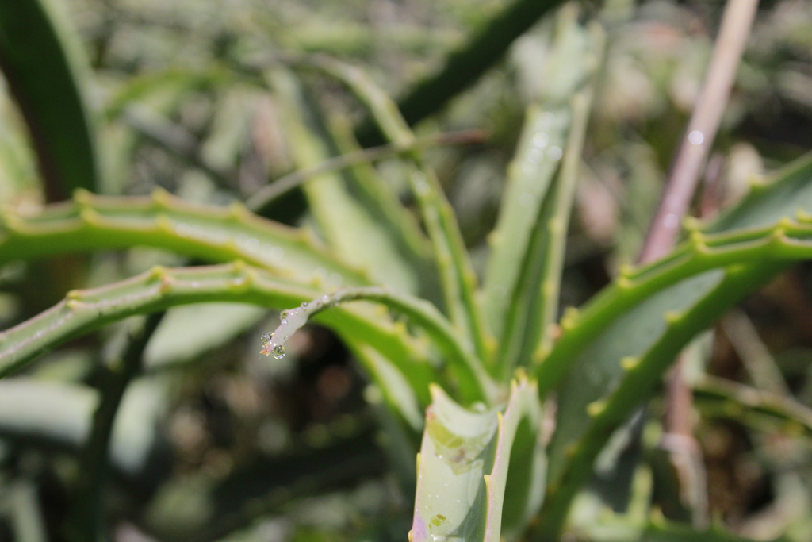
Caption: The researchers found that agave leaves have an inner core that remains highly hydrated while the outer layer acts as a protective barrier to reduce water loss.
Credit: Enrique Castro, CIO
For terahertz imaging, the researchers used a time-domain terahertz spectrometer with a femtosecond fiber laser and sub-mm pixel resolution. They placed thin leaf slices between a terahertz emitter and detector and then used the water absorption measurements to map hydration levels. They reconfigured the same time-domain terahertz spectrometer to an attenuated total reflection geometry to analyze solutions containing fructan.
“Our research introduces several key innovations in the study of plant hydration using terahertz technology,” said Monica Ortiz-Martinez. “One of the most significant advancements is non-invasive water detection — unlike traditional methods that require cutting, drying and weighing plant samples, terahertz imaging enables real-time hydration analysis without damaging the plant.”
The analysis revealed that agave leaves have a specialized water storage system, where the leaf’s inner core remains highly hydrated while the outer layer acts as a protective barrier to reduce water loss. The researchers also found that fructans have an exceptional ability to attract and hold on to water molecules around them, far stronger than other sugars. This is because the branched chemical structure of fructans forms a kind of porous sponge on which water can be retained to keep the plant hydrated despite high temperatures.
The combination of tissue-level water storage and molecular-level water retention make agaves highly drought-resistant, enabling them to thrive in arid environments where water is scarce.
Expanding the technology
Next, the researchers plan to expand the use of terahertz spectroscopy and imaging to study drought resistance in a wider range of plant species. They want to investigate how different plants manage water at both the tissue and molecular levels, particularly crops that are essential for global food security.
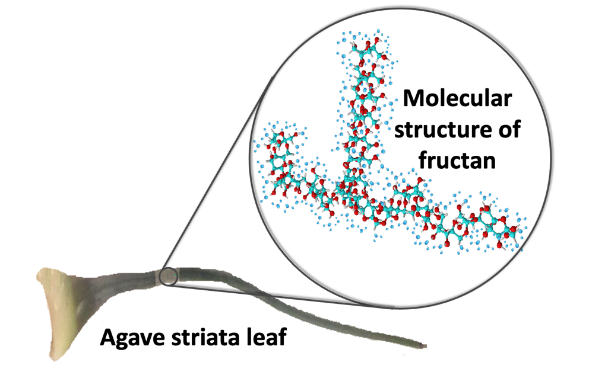
Caption: The analysis showed that fructans have a branched chemical structure that forms a kind of porous sponge on which water can be retained. This keeps the plant hydrated despite high temperatures. The illustration shows an Agave striata leaf and the molecular structure of its fructans, with water molecules bound around the fructan chains.
Credit: Monica Ortiz-Martinez, CIO
The researchers say that with further development, the setup, which is currently optimized for laboratory use, could be made into a portable and cost-effective terahertz system that could be used in fields or greenhouses for monitoring. Combining this with advanced machine learning algorithms to analyze terahertz images more efficiently could enable real-time detection of hydration patterns and drought stress indicators.
The researchers emphasize that achieving results with meaningful social and economic impact requires strong interdisciplinary collaboration, with close cooperation between experts in optics, plant physiology and food science being key in this study.
“By advancing non-invasive plant monitoring methods, our research lays the foundation for smarter, more sustainable agricultural practices, ultimately benefiting both farmers and consumers while helping to conserve natural resources for future generations,” said Castro-Camus.
Paper: E. Castro-Camus, A. K. Singh, A. V. Perez-Lopez, J. A. Morales-Hernandez, J. Simpson, S. J. Villanueva-Rodriguez, M. Ortiz-Martinez, “Terahertz spectroscopy and imaging as a tool to unlock physiological and molecular mechanisms for drought resistance of agaves,” Applied Optics, 64, 2057-2062 (2025).
DOI: https://doi.org/10.1364/AO.547952

